VS2010 MFC编程---OpenGL连接与坐标系绘制

cg3DTrans项目创建说明略。
1、3D坐标场景变换参数定义&初始化
（1）Ccg3DTransDoc类头文件Ccg3DTransDoc.h中定义3D坐标场景变换参数:
场景平移参数 float m_translateVector[3]
场景旋转参数 float m_xAngle,m_yAngle,m_zAngle
代码如下:
class Ccg3DTransDoc : public CDocument
{
protected:
Ccg3DTransDoc();
DECLARE_DYNCREATE(Ccg3DTransDoc)

// 特¬?性?
public:
float m_translateVector[3]; // Scene Translation parameters.
float m_xAngle,m_yAngle,m_zAngle; // Scene Rotation parameters.
……
（2）Ccg3DTransDoc类源文件Ccg3DTransDoc.cpp构造函数中初始化3D坐标场景变换参数，代码如下:
Ccg3DTransDoc::Ccg3DTransDoc()
{
// Scene Translate and Rotate parameters.
m_xAngle = 10.0f;
m_yAngle = -40.0f;
m_zAngle = 0.0f;
m_translateVector[0] = -0.0f;
m_translateVector[1] = -0.3f;
m_translateVector[2] = -5.0f;

}

2、OpenGL连接与坐标系绘制
（1）Ccg3DTransView类添加显示格式设置函数。
BOOL Ccg3DTransView::bSetupPixelFormat()
{
static PIXELFORMATDESCRIPTOR pfd =
{
sizeof(PIXELFORMATDESCRIPTOR), // size of this pfd
1, // version number
PFD_DRAW_TO_WINDOW | // support window
PFD_SUPPORT_OPENGL | // support OpenGL
PFD_DOUBLEBUFFER, // double buffered
PFD_TYPE_RGBA, // RGBA type
24, // 24-bit color depth
0, 0, 0, 0, 0, 0, // color bits ignored
0, // no alpha buffer
0, // shift bit ignored
0, // no accumulation buffer
0, 0, 0, 0, // accum bits ignored
32, // 32-bit z-buffer
0, // no stencil buffer
0, // no auxiliary buffer
PFD_MAIN_PLANE, // main layer
0, // reserved
0, 0, 0 // layer masks ignored
};
int pixelformat;

if ( (pixelformat = ChoosePixelFormat(m_pDC->GetSafeHdc(), &pfd)) == 0 ) {
MessageBox(_T("ChoosePixelFormat failed"));
return FALSE;
}

if (SetPixelFormat(m_pDC->GetSafeHdc(), pixelformat, &pfd) == FALSE) {
MessageBox(_T("SetPixelFormat failed"));
return FALSE;
}

return TRUE;
}

（2）重载Ccg3DTransView类的WM_CREATE和WM_SIZE函数, 代码如下:

int Ccg3DTransView::OnCreate(LPCREATESTRUCT lpCreateStruct)
{
if (CView::OnCreate(lpCreateStruct) == -1)
return -1;

PIXELFORMATDESCRIPTOR pfd;
int n;
HGLRC hrc;
GLfloat fAspect;

m_pDC = new CClientDC(this);

ASSERT(m_pDC != NULL);

if (!bSetupPixelFormat()) return 0;

n = ::GetPixelFormat(m_pDC->GetSafeHdc());
::DescribePixelFormat(m_pDC->GetSafeHdc(), n, sizeof(pfd), &pfd);

// CreateRGBPalette();

hrc = wglCreateContext(m_pDC->GetSafeHdc());
wglMakeCurrent(m_pDC->GetSafeHdc(), hrc);

glClearDepth(100.0f);
glShadeModel(GL_FLAT);
glEnable(GL_NORMALIZE);
glDepthFunc(GL_LEQUAL);
glEnable(GL_DEPTH_TEST);
glEnable(GL_AUTO_NORMAL);
GetClientRect(&m_viewRect);

if (!m_viewRect.bottom) fAspect = 1.0f;
else fAspect = (GLfloat)m_viewRect.right/m_viewRect.bottom;

glMatrixMode(GL_PROJECTION);
glLoadIdentity();
gluPerspective(45.0f, fAspect, 3.0f, 7.0f);
glMatrixMode(GL_MODELVIEW);
return 0;

return 0;
}

void Ccg3DTransView::OnSize(UINT nType, int cx, int cy)
{
CView::OnSize(nType, cx, cy);

if (cy > 0)
{
glViewport(0, 0, cx, cy);

if((m_viewRect.right > cx) || (m_viewRect.bottom > cy))
RedrawWindow();

m_viewRect.right = cx;
m_viewRect.bottom = cy;

glMatrixMode(GL_PROJECTION);
glLoadIdentity();
gluPerspective(45.0f, (GLdouble)cx/cy, 3.0f, 7.0f);
glMatrixMode(GL_MODELVIEW);
}
}

（3）Ccg3DTransView类添加3D场景绘制函数。
void Ccg3DTransView::DrawScene()
{
static BOOL bBusy = FALSE;
Ccg3DTransDoc* pDoc = (Ccg3DTransDoc*)GetDocument();

if (bBusy) return;

bBusy = TRUE;

glClearColor(0.0f, 0.0f, 0.0f, 1.0f);
glClear(GL_COLOR_BUFFER_BIT | GL_DEPTH_BUFFER_BIT);

glPushMatrix();
glTranslatef(pDoc->m_translateVector[0],
pDoc->m_translateVector[1],
pDoc->m_translateVector[2]);
glRotatef(pDoc->m_xAngle, 1.0f, 0.0f, 0.0f);
glRotatef(pDoc->m_yAngle, 0.0f, 1.0f, 0.0f);
glRotatef(pDoc->m_zAngle, 0.0f, 0.0f, 1.0f);
glScalef(0.3f, 0.3f, 0.3f); /* Make Scene Smaller Enough to Look */

// if (m_drawScene) m_drawScene->DrawScene();
// Draw Space Axis
glColor3f(1.0f, 0.0f, 0.0f);
glBegin(GL_LINES); // X Axis
glVertex3f( 6.0f, 0.0f, 0.0f);
glVertex3f(-6.0f, 0.0f, 0.0f);
glEnd();
glColor3f(0.0f, 1.0f, 0.0f);
glBegin(GL_LINES); // Y Axis
glVertex3f( 0.0f, 6.0f, 0.0f);
glVertex3f( 0.0f, -6.0f, 0.0f);
glEnd();
glColor3f(0.0f, 1.0f, 1.0f);
glBegin(GL_LINES); // Z Axis
glVertex3f( 0.0f, 0.0f, 6.0f);
glVertex3f( 0.0f, 0.0f, -24.0f);
glEnd();

glPopMatrix();

glFinish();
SwapBuffers(wglGetCurrentDC());

bBusy = FALSE;

// Notify CCgTransControl can process the Project Result to PictureBox 'PROJECTPANE'
// if (pDoc->rayTraceSelect != CVIEWRAYTRACE)
pDoc->UpdateAllViews(this);
}

（4）Ccg3DTransView类OnDraw（）调用DrawScene（）。
void Ccg3DTransView::OnDraw(CDC* /*pDC*/)
{
Ccg3DTransDoc* pDoc = GetDocument();
ASSERT_VALID(pDoc);
if (!pDoc)
return;

DrawScene();
}

3、OpenGL库连接配置
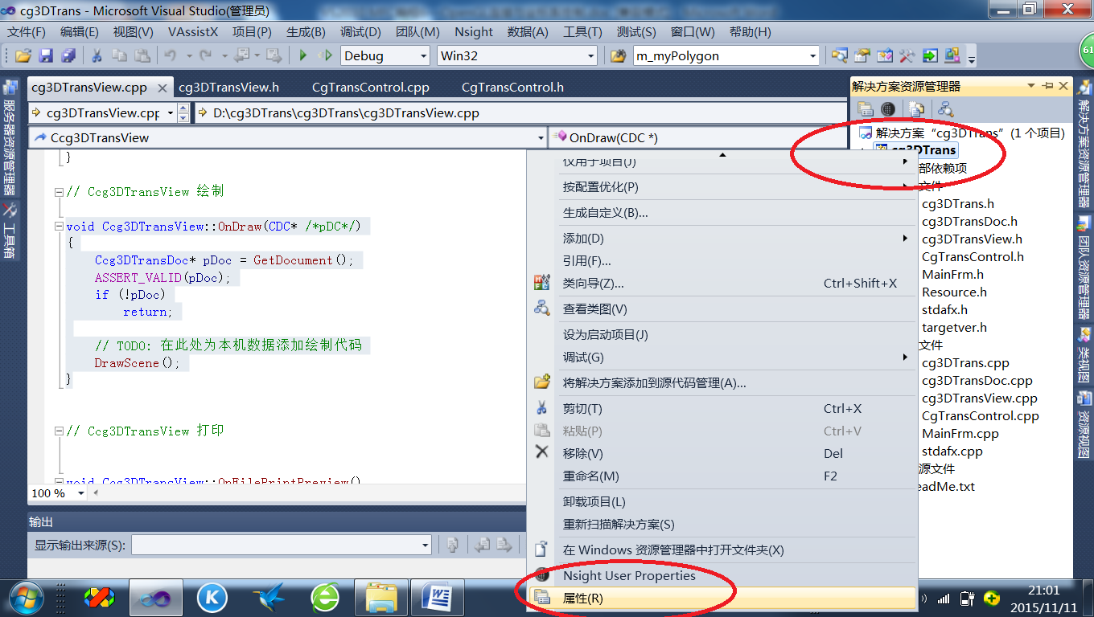

编辑修改项目属性中链接器的输入选项，在附加依赖项栏填入OpenGL库描述：opengl32.lib;glu32.lib;glut32.lib;
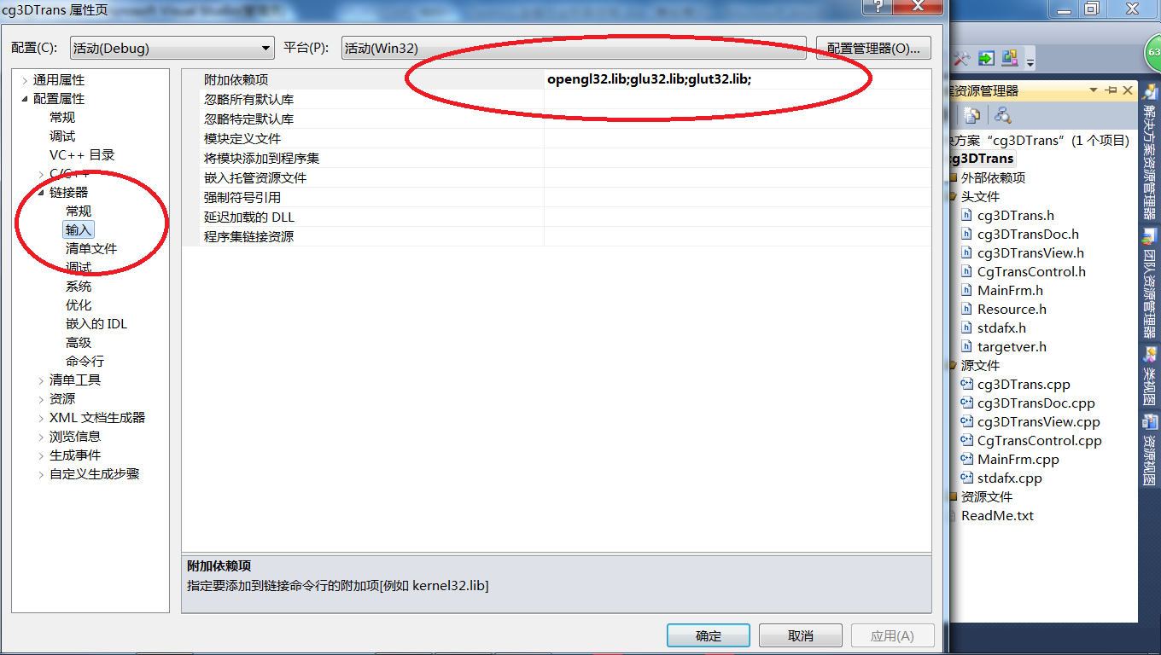

4、编译运行
